Executive Director

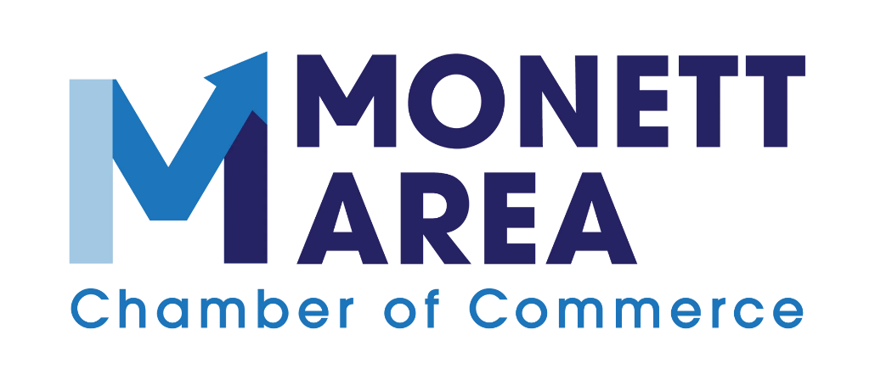

Job Description

Executive Director

Definition
The Executive Director is the top administrative employee of the Chamber, The Director is responsible for all administrative and management functions, following the bylaws and policy guidelines of the of. The Director executes the mission of the organization by planning, directing, and overseeing all activities of the Chamber. Other key duties include fundraising, marketing, and community outreach. This position reports directly to the Chamber’s Board of Directors.
Board Governance:
The Director leads the Chamber in a manner that supports and guides the organization’s mission as defined by the Board of Directors. The Director is responsible for communicating effectively with the Board and providing, in a timely manner and accurate manner, all information necessary for the Board to function properly and make informed decisions.
Financial Performance & Viability:
Develop resources sufficient to ensure the financial health of the Chamber.
The Director is responsible for the fiscal integrity of the Chamber which includes submission to the Board of an annual budget and monthly financial statements, which accurately reflect the financial condition of the organization. The Director is responsible for fiscal management that operates within the approved budget, ensures maximum resource utilization, and maintenance of the organization towards a positive financial position.

Essential Job Functions
Mission and Core Values | Serves as an ambassador of the mission and purpose of The Monett Area Chamber of Commerce.
Mission and Core Values | Promote pride and progress by enhancing the industrial and business environment and quality of life in our community.
Administration & Personnel Management | Reports monthly to the Executive Committee and Board of Directors on membership, finances, economic development, analyzing challenges and opportunities.
Administration & Personnel Management | Create monthly board meeting agendas and supporting documentation, as directed by the President of Board.
Administration & Personnel Management | Guide implementation of strategic plan outlining the goals and objectives of the Board of Directors.
Administration & Personnel Management | Manage staff, including workplace policies and procedures, hiring and termination of employees with expressed consent of the Board of Directors, scheduling, performance reviews, and human resources compliance.
Administration & Personnel Management | Oversee all financial statements and transactions concerning monthly banking accounts reconciliations, bill payments, payroll, profit and loss reporting, budget vs. actual statements.
Administration & Personnel Management | Creatively develop methods to grow non-dues revenues.
Administration & Personnel Management | Maintain communication with Chamber officers, staff, committees, members, and public.
Administration & Personnel Management | Ensure compliance with all legal, regulator, and ethical standards.
Membership & Marketing | Oversee and plan projects and events within timelines and budgetary constraints.
Membership & Marketing | Retain and increase membership through programs and services to meet member needs.
Membership & Marketing | Oversee and attend chamber events, including networking meetings and lunches that promote business growth and networking opportunities.
Membership & Marketing | Manage and distribute weekly digital communications, including email campaigns, social media posts, and related online content.
Leadership and Communication | Demonstrates the ability to foster strong communication, collaboration, and relationships with stakeholders and members of the community.
Leadership and Communication | Works collaboratively with local school systems, city and county government officials, area industries, businesses, and Monett Area Chamber members to strengthen community partnerships and support economic and community development initiatives.
Leadership and Communication | Handles detailed correspondence.
This list is intended to be illustrative of the responsibilities of the position and is not a comprehensive listing of all functions and tasks. The Monett Area Chamber of Commerce retains the right to modify or change the duties or essential functions of the job at any time.
Required Knowledge, Skills, and Abilities
Considerable knowledge of chamber operations, nonprofit governance, and board procedures, including applicable rules, regulations, and best practices

Highly motivated, results and detail oriented, and a creative thinker who can apply logical thinking to complex situations

Proficiency in technology and communication tools, including website administration, social media management, creation of weekly member/community updates, and coordination of annual event calendars

Communication skills include verbal, written, listening skills, ability to present and persuade

Strong financial experience including understanding balance sheets, profit and loss statements, developing yearly budget and general financial practices.

Ability to exercise good judgment and discretion

Ability to work varied and flexible hours and accept and adapt to changes in assignments, methods, and policies

High level of professionalism and confidentiality

Ability to understand and follow direction and adapt to changes in methods and policies.

Satisfactory background (criminal/employment) and credit checks

A licensed and insured driver

Minimum Experience and Training Qualifications
The following statement represents the minimum experience and training standards that will be used to admit or reject applicants for evaluation, provided that equivalent substitution will be permitted in case of deficiencies in either experience or education.

- Associate’s or Bachelor’s degree in Communications, Nonprofit Management, Marketing, Public Relations, or a related field preferred
- 2 Years of experience in related field
- The Chamber prefers a candidate who lives in and is familiar with the communities served by the organization

Traits and Characteristics Desired
The Executive Director will be a person who is passionate about supporting the local community, serving Chamber members, fostering meaningful partnerships, and promoting economic and community growth.
The Executive Director should have outstanding critical thinking skills and effective communication qualities as demonstrated by success in prior experience.

Must possess the ability to cultivate and strengthen individual and team relationships to support successful Chamber programs, community initiatives, and member engagement efforts.

The Executive Director must demonstrate the ability to establish rapport, communicate effectively, and foster a positive and collaborative work culture with staff, Chamber members, community partners, and internal and external stakeholders.

Demonstrates empathy, professionalism, effective conflict resolution, exceptional communication, and strong follow-up skills.

The Executive Director must be adaptable and able to thrive in a fast-paced environment while maintaining a strong work ethic, effective delegation skills, and sound time management abilities.

The Executive Director should be open to feedback, possess a growth mindset, and demonstrate a commitment to ongoing professional development and continuous improvement for both themselves and the Chamber.

Compensation and Benefits
Salary is dependent on experience and qualifications.
Paid sick leave, paid time, and paid holidays.
Health Insurance stipend
Potential for bonuses
Ongoing training with personal and professional development opportunities
Flexible schedule to compensate for evening and weekend activities.
Car allowance, plus mileage (when traveling over 50 miles from Monett)

I HAVE READ AND UNDERSTAND THE ABOVE JOB DESCRIPTION. I AGREE TO ABIDE BY ALL Monett Area Chamber of Commerce RULES AND REGULATIONS.
Date | Signature

